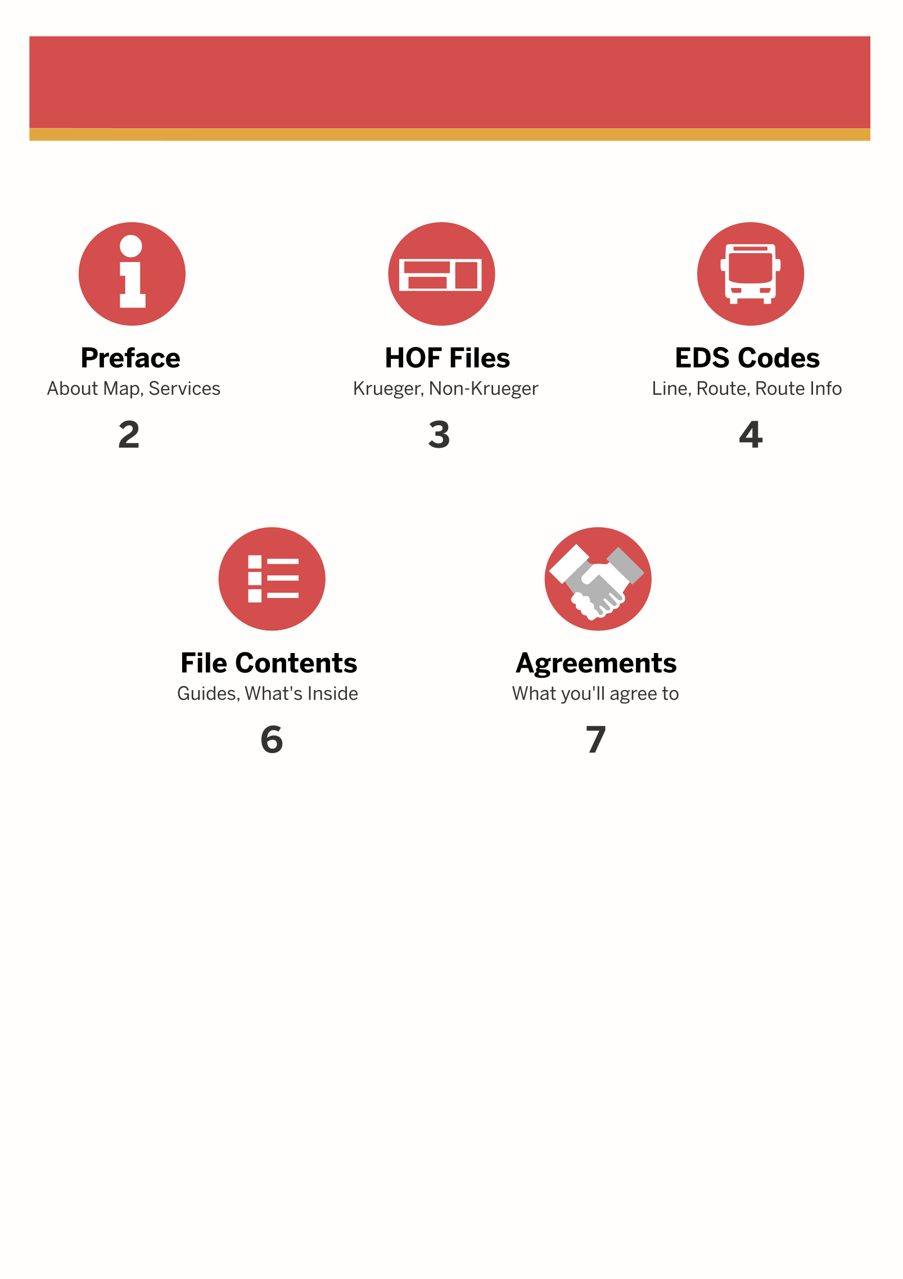

**Contents**



**974** – Tomlinson Int (Loops at Townsville Ave 1)

**974A** – Ends at Opp Townsville Poly

**974M** – West Terra Int (Loops at Townsville Link)

**975** – Tomlinson Int (Loops at Woodneuk Cemy)

**976** – Tomlinson Int (Loops at Brickland North 6)

**979** – Tomlinson Int (Loops at Long Hill Drive)

**981** – Hillgrove Int (Loops at Burlington Close)

**982** – Hillgrove Int (Loops at Brickland Crescent)

**984** – West Terra Int (Loops at Budget Terminal)

**987** - Hillgrove Int (Loops at Tennessee Hill St 1, Hilltop Ave)

**988** - Hillgrove Int (Loops at Hillgrove Link)

**989** – Hillgrove Int (Loops at Rosemary Estate)

**990** – Hospital Avenue Ter (Loops at Edgeville Hill)

**991** - Hospital Avenue Ter (Loops at Tennessee Drive)

**Services**



**Preface**

**About Map**

Hillgrove City is a map made in-house by SMRT Virtual Studios. This map includes 15 services – 974/A/M, 975, 976, 979, 981, 982, 983, 984, 987, 988, 989, 990 and 991.



**EDS Types**

This map is compatible with Buses using Chura Krueger, and Buses not using the system. The package contains both the HOF Files.



Non-Krueger

Krueger Compatible

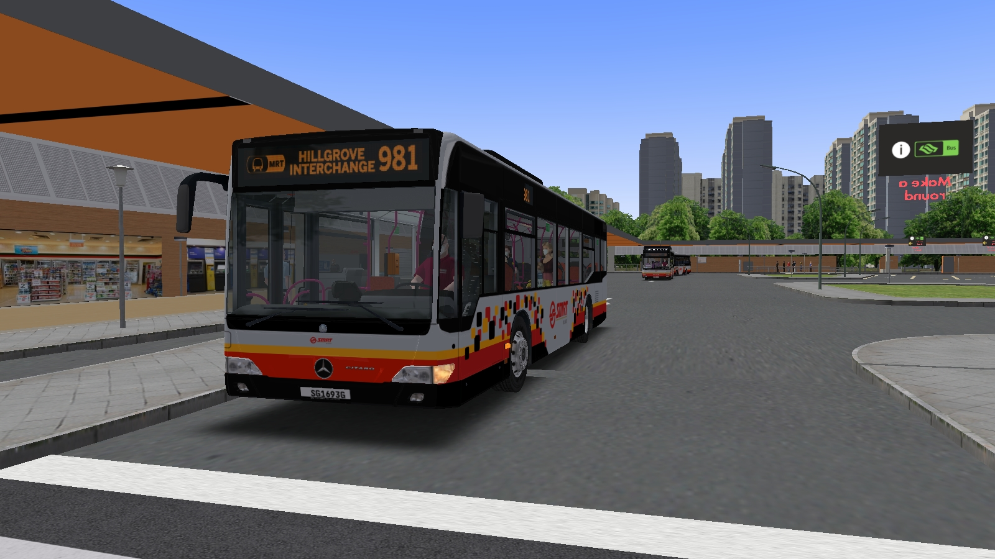

**HOF Files**

|  |  |  |  |  |
| --- | --- | --- | --- | --- |
| **Line** | **Route** | **Dest. Code** | **Route Info** | **Remarks** |
| **97400** | **01** | **974** | Tomlinson Int via Townsville Ave 1 |  |
| **02** | **994** | Ends at Opp Townsville Poly | Peak Hours only (AM & PM) |
| **03** | **997** | West Terra Int via Townsville Link |  |
| **97500** | **01** | **975** | Woodneuk via Woodneuk Town Cemetery |  |
| **02** | **996** | Tomlinson Int via Woodneuk Town Cemetery | Optional |
| **97600** | **01** | **976** | Tomlinson Int via Brickland North 6 |  |
| **97900** | **01** | **979** | Tomlinson Int via Long Hill Drive |  |
| **98100** | **01** | **981** | Hillgrove Int via Burlington Close |  |
| **98200** | **01** | **982** | Hillgrove Int via Brickland Cres |  |
| **98300** | **01** | **983** | West Terra Int via Hillgrove Int |  |
| **98400** | **01** | **984** | West Terra Int via Budget Terminal |  |
| **98700** | **01** | **987** | Hillgrove Int via Tennessee Hill St 1, Hilltop Ave |  |
| **98800** | **01** | **988** | Hillgrove Int via Hillgrove Link |  |
| **98900** | **01** | **989** | Hillgrove Int via Rosemary Estate |  |
| **99000** | **01** | **990** | Hospital Avenue Ter via Tennessee Drive |  |
| **99100** | **01** | **991** | Hospital Avenue Ter via Tennessee Drive |  |
|  |  | **000** | SMRT Logo | Blank |
|  |  | **001** | EDS Info | EDS Matrix Renderer |
|  |  | **002** | Messages | Messages |

**EDS Codes**

|  |  |  |  |  |
| --- | --- | --- | --- | --- |
|  |  | **003** | Out Of Service |  |
|  |  | **004** | Training Bus |  |

**Setting Up Guide**

Step 1 – Download the files via [Discord](https://discord.com/invite/pCjrwqApfC). Accept the Invitation (if this is your first time), and navigate to **#hillgrove-town**



**Package consists of:**



* **Fresh Start** – Consists of everything you need for the map to work
* **Updates** – Consists of files that got updated
* **2 Hof Files** – [K++] Hillgrove Town & Hillgrove Town
* **Readme PDF** (this)

**File Contents**

Step 3 – If you intend to use the Stable Version, simply click the link to download the files. However, if you intend to use the Preview Version, you’ll need to request to join the preview. Alternatively, you can use [**Github**](https://github.com/smrtgVirtual/hillgrove-town).

Step 2 – If you intend to use the Stable Version, simply click the link to download the files. However, if you intend to use the Preview Version, you’ll need to request to join the preview. Alternatively, you can use [**Github**](https://github.com/smrtgVirtual/hillgrove-town).